SMART IRRIGATION SYSTEM USING AI

-Report by Surya Reddy

Agriculture is a field of unlimited possibilities

**Abstract**

India's agriculture faces many difficulties, notably in making the best use of water supplies and improving irrigation techniques. In order to work through these problems, the forward rural Watching unit uses information analytics and the Internet of Things (IoT) sensors to provide realtime information on soil moisture and temperature. With the help of this system, farmers can increase crop yield, improve irrigation schedules, and make well-informed decisions. It is a versatile system that is easy to employ, with a cloud-based information processing program and affordable sensors that are seamlessly integrated into the recommended solution. The goal of this system is to improve small and medium-sized farms and promote sustainability and productivity in Indian agriculture by integrating cutting-edge technologies with conventional farming methods. The account provides a general roadmap for the execution of this cutting-edge rural drive, outlining the key components, specifications, abstract framework, and potential impact.

**Problem Statement**

Traditional irrigation methods in small farms across India are often inefficient, leading to significant water wastage and inconsistent crop yields. Farmers struggle to effectively manage irrigation schedules due to limited access to real-time information on soil moisture, weather conditions, and crop water requirements. This inefficiency not only depletes valuable water supplies but also impacts the profitability and sustainability of farming operations. In addition, the capricious nature of weather patterns and soil conditions exacerbates these challenges, leaving farmers with limited tools to respond promptly.

The lack of affordable and accessible technological solutions has further hindered the adoption of modern irrigation practices. As a result, there is a pressing need for a cost-effective and efficient smart irrigation system that leverages IoT sensors and AI-driven data analytics to provide realtime insights. Artificial intelligence algorithms can process the collected data to optimize irrigation schedules, detect anomalies, and provide actionable recommendations. This system would empower farmers to improve water usage, enhance crop health, and increase agricultural productivity, thereby promoting sustainable farming practices and enhancing the livelihoods of small-scale farmers in India.

**Business Need Assessment**

Target Market: Small-scale farms in rural India, focusing on high-value crops.

Customer Segments: Small farmers, agricultural cooperatives, government bodies, and NGOs.

Pain Points: Water scarcity, labor shortages, low yields, high costs, climate variability, inefficient irrigation.

Market Size: 86% of Indian farms are small/marginal, indicating a large market potential.

Competitive Landscape: Traditional and drip irrigation systems. Our system offers AI and IoT-driven real-time insights, improving efficiency and cost-effectiveness.

Market Trends: Increasing acceptance of digital farming solutions, driven by government initiatives. Focus on sustainability and resource conservation.

Potential Impact: Increased crop yields, reduced costs, improved farmer incomes, and enhanced farming sustainability through efficient resource use.

**Target Specifications and Characterization**

**Customer Characteristics**

Small-scale farmers: The principal operators are farmers with less than 5 acres of farming area. These farmers are looking for affordable, easy-to-use technology to improve their farming practices. Agricultural Cooperatives: Groups of farmers who manage collective resources and seek to improve their irrigation methods through shared technology. Government Bodies/NGOs: Organizations focused on improving rural agricultural productivity and sustainability, often through subsidies or direct support to farmers.

**User Requirements**

Affordability: The system must be cost-effective to fit within the financial constraints of smallscale farmers. Ease of Use: The system should be simple to use, with minimal training required. Farmers need to easily understand and operate the system. Durability: Given the harsh environmental conditions, the system hardware needs to be robust and weather-resistant. Expandability: The system needs to be scalable to allow expansion to larger areas or integration with additional features over time. Real-time Information: Farmers require real-time information on soil moisture, weather conditions, and crop health to make informed decisions. Energy Efficiency: The system should have low power consumption, potentially incorporating solar power to reduce reliance on erratic electricity sources. Localized language support: Interfaces and alerts need to be available in local languages to ensure comprehensibility.

**Applicable Constraints**

I. Financial: Initial investment and maintenance costs could be high for small-scale farmers.Dependence on government subsidies or financial aid to make the technology affordable.

II. Technical: Reliable power supply and data accuracy concerns and scalability to accommodate different farm sizes.

III. Operational: Need for farmer training and language accessibility. Regular maintenance and calibration of sensors.

IV. Environmental: Hardware needs to be weather-resistant. Use of sustainable and eco-friendly materials.

**Concept Development**

The Smart Agricultural Monitoring System optimizes irrigation and crop yields using IoT sensors, AI, and data analytics. It monitors soil moisture, environmental conditions, and crop health, providing real-time insights and recommendations via a user-friendly mobile app. Designed for scalability and reliability, it undergoes rigorous testing and iterative improvements based on farmer feedback before deployment.

Code Link:

Kaggle dataset: <https://www.kaggle.com/code/theeyeschico/crop-analysis-and-prediction/input>

**Analysis of crop datasets**

The code processes a dataset containing readings of **Nitrogen (N)**, **Phosphorus (P)**, **Potassium (K)**, **Temperature**, **Humidity**, **pH**, and **Rainfall** over time. The key components of the code are:

1. **Data Collection**: The system reads sensor data for each time step from the dataset.
2. **Data Analysis**: The code checks whether certain conditions are met (e.g., nutrient levels, temperature, humidity) that would trigger irrigation.
3. **Irrigation Decision**: If the conditions indicate that the crop needs water, the system simulates irrigation by adding a fixed amount of water (50 units) to the total water usage.
4. **History Logging**: Each step's data, including whether irrigation occurred and how much water was used, is logged for further analysis.
5. **Visualization**: The code generates plots showing the trends of the various parameters over time, helping users understand the environmental conditions and irrigation decisions.

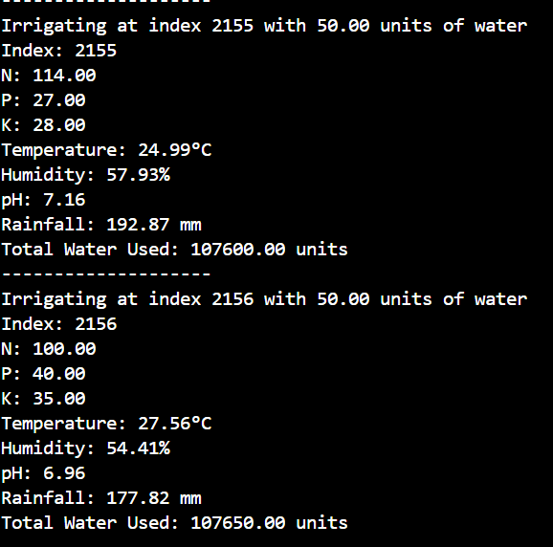

**Irrigation Events**: The system outputs logs whenever irrigation is performed. For example:

* At index 2199, 50 units of water were used when Nitrogen was 117, Phosphorus was 32, and other parameters were recorded.
* The total cumulative water used is tracked, reaching 109850 units by the end.

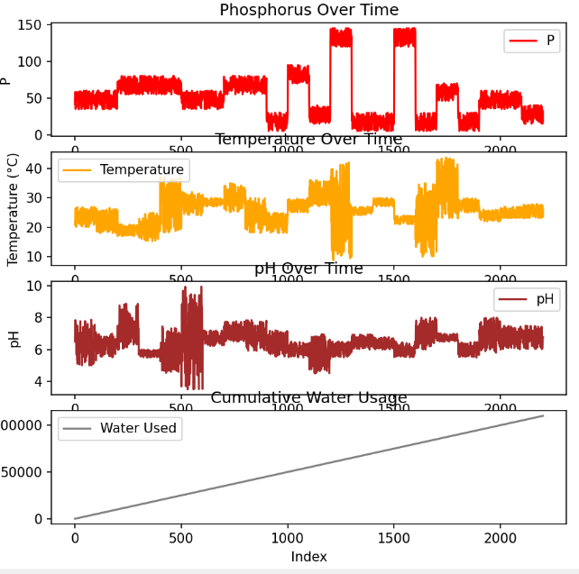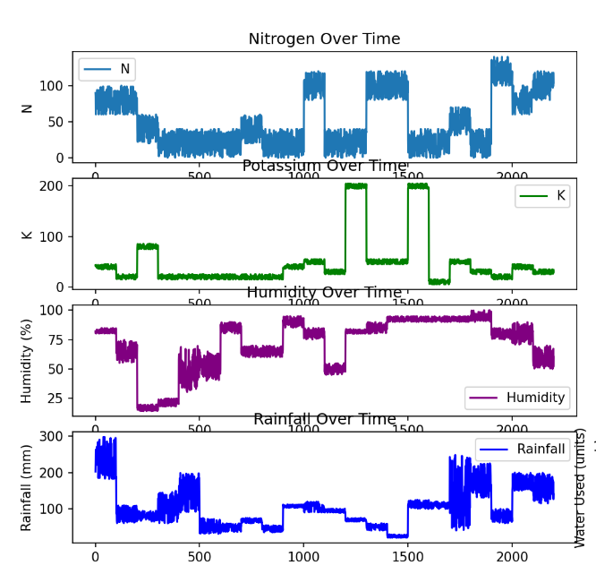**Visual Trends**: The image provided shows how parameters like Nitrogen, Potassium, Humidity, and Rainfall change over time. This helps in visualizing the factors that influenced irrigationdecisions.

**Final Prototype**

The **Smart Agricultural Monitoring System** is designed to provide comprehensive real-time monitoring and data-driven insights for farmers, aiming to optimize irrigation schedules, enhance crop health, and increase overall agricultural efficiency. Below is a detailed description of the final product, including a schematic diagram illustrating the system's workflow.

**Detailed Product Description:**

The Smart Agricultural Monitoring System comprises the following key components:

1. **IoT Sensors**:
   * **Types**: Soil Moisture, Temperature, Humidity, Crop Health.
   * **Function**: Collect real-time data from the farm environment.
2. **Central Hub**:
   * **Function**: Receives data wirelessly transmitted from IoT sensors and forwards it to the cloud server.
3. **Cloud Server**:
   * **Functions**: Data storage, processing, analytics, and AI-driven insights.
   * **Technologies Used**: Big data analytics, machine learning algorithms.
4. **Mobile App**:
   * **Functions**: Provides a user-friendly interface for farmers to view real-time data, receive actionable insights, and manage their farms effectively.
   * **Features**: Real-time monitoring, historical data trends, predictive analytics, alerts, and recommendations.

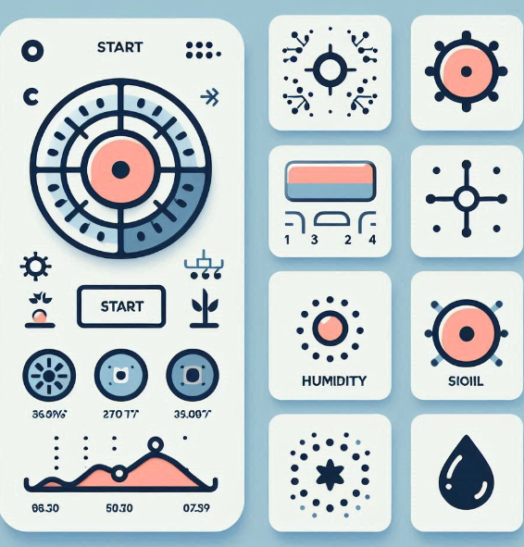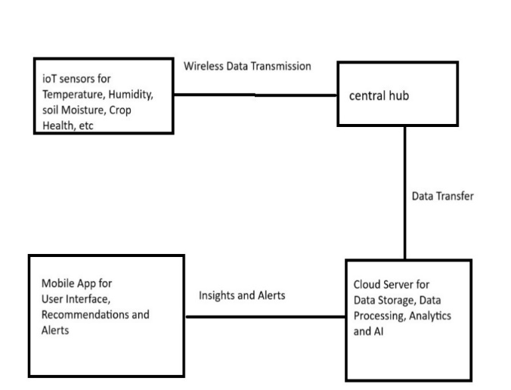

**Technical Specifications:**

* **IoT Sensors**:
  + Soil Moisture Sensor: Measures the volumetric water content in soil.
  + Temperature Sensor: Monitors the ambient temperature of the environment.
  + Humidity Sensor: Measures the moisture level in the air.
  + Crop Health Sensor: Utilizes multispectral imaging to assess plant health.
* **Central Hub**:
  + **Components**: Microcontroller unit, wireless transceiver.
  + **Function**: Aggregates sensor data and transmits it to the cloud server via Wi-Fi or cellular network.
* **Cloud Server**:
  + **Components**: High-performance servers, big data storage solutions.
  + **Software**: Machine learning frameworks (e.g., TensorFlow, Scikit-learn), data analytics platforms (e.g., Apache Spark).
  + **Function**: Processes incoming data, performs analytics, and generates actionable insights.
* **Mobile App**:
  + **Platforms**: Android, iOS.
  + **Features**: User-friendly interface, real-time data visualization, historical data analysis, predictive analytics, customizable alerts.

**Operational Workflow:**

1. **Data Collection**: IoT sensors continuously monitor soil moisture, temperature, humidity, and crop health, transmitting data wirelessly to the central hub.
2. **Data Transmission**: The central hub collects the sensor data and sends it to the cloud server for processing.
3. **Data Processing**: The cloud server stores the data, applies machine learning algorithms, and generates insights and recommendations.
4. **User Interaction**: Farmers access the mobile app to view real-time data, receive alerts and recommendations, and manage their farm operations based on the insights provided.

**How does it work?**

**Data Collection:**

IoT Sensors: Installed in the field, these sensors collect data on soil moisture, temperature, humidity, and crop health.

Transmission: The collected data is transmitted wirelessly to a central server or cloud storage.

**Data Storage:**

Database: A centralized database stores the incoming data from the sensors for further analysis and historical reference.

**Data Analysis:**

Machine Learning Models: Analyze the collected data to generate insights and predict optimal irrigation schedules.

Predictive Analytics: Forecast future environmental conditions and recommend irrigation actions to optimize water usage and crop health.

**Data Sources**

Soil Moisture Sensors: Measure the moisture content in the soil to determine irrigation needs.

Temperature and Humidity Sensors: Track environmental conditions that affect crop growth.

Crop Health Sensors: Monitor the health of the crops, detecting signs of stress or disease early.

Weather Data: Integrates external weather data to enhance predictive models.

Algorithms, Frameworks, Software, etc. Needed

Machine Learning Algorithms: Decision trees, random forests, or neural networks for predictive modeling.

IoT Frameworks: For device communication and data transmission (e.g., MQTT, CoAP).

Backend Software: Flask or Django for API development and data handling.

Database Systems: SQL (e.g., PostgreSQL) or NoSQL (e.g., MongoDB) for data storage.

Mobile Development Frameworks: React Native or Flutter for building cross-platform mobile applications.

Data Visualization Tools: Libraries like D3.js or Chart.js for visualizing data in the mobile app.

Cloud Services: AWS, Google Cloud, or Azure for hosting and scalability.

Team Required to Develop

Agronomist / Agricultural Specialist: Provides expertise on crop management and irrigation practices.

Data Scientist / Analyst: Analyzes sensor data and develops predictive models.

Software Developer / Engineer: Designs and develops the mobile application and backend infrastructure.

Hardware Engineer / IoT Specialist: Selects and integrates IoT sensors and ensures their proper installation and functioning.

Project Manager / Coordinator: Oversees the project, manages timelines, and coordinates tasks among team members.

**Business Model**

For the Smart Irrigation System Using AI, we can implement a multi-tiered business model:

a) Hardware Sales: One-time sale of IoT sensors, central hub, and other necessary hardware.

b) Software as a Service (SaaS): Monthly or annual subscription for access to the mobile app and cloud-based analytics platform.

c) Tiered Pricing:

* Basic Tier: Essential features for small farms
* Premium Tier: Advanced analytics and customization for larger farms
* Enterprise Tier: Full suite of features with dedicated support for large agricultural businesses

d) Installation and Maintenance Services: Offering professional installation and regular maintenance as additional services.

e) Data Insights: Selling anonymized, aggregated data insights to agricultural research institutions or government agencies.

f) Partnerships: Collaborate with agricultural input providers (seeds, fertilizers) to offer bundled solutions.

Financial Equation

**Revenue = Hardware Sales + Subscription Revenue + Service Revenue + Data Insights Revenue**

**Hardware Sales:** The income generated from selling physical products, such as devices or equipment.

**Subscription Revenue:** Earnings from customers who pay regularly (e.g., monthly or annually) for access to a service or product.

**Service Revenue:** Income from offering services like maintenance, support, or installation.

**Data Insights Revenue:** Earnings from selling insights derived from data analysis, which could include trends, predictions, or custom reports.

Profit = Revenue - (Cost of Goods Sold + Operating Expenses + Marketing Expenses + R&D Expenses)

Break-even Point = Fixed Costs / (Price per Unit - Variable Cost per Unit)

Customer Lifetime Value (CLV) = (Average Revenue per User * Gross Margin %) / Churn Rate

Return on Investment (ROI) = (Net Profit / Total Investment) * 100

**Business Opportunity**

**Hardware Sales:** Sell specialized IoT devices and sensors tailored to agriculture.

**Subscription Revenue:** Offer tiered subscription plans for advanced analytics and real-time monitoring.

**Service Revenue:** Provide installation, maintenance, and training services.

**Data Insights Revenue:** Sell collected data insights to agribusinesses, researchers, and government bodies.

**Partnerships:** Collaborate with agricultural suppliers for bundled product offerings.

**Educational Programs:** Offer training to farmers, potentially partnering with universities and NGOs.

**Government Contracts:** Secure contracts and subsidies for large-scale deployments.

**Custom Software Development:** Create customized software solutions for specific farming needs.

**International Expansion:** Enter new markets with localized products and services.

**Sustainability Branding:** Promote the environmental benefits to attract conscious customers.

**Integration with Other Technologies:** Develop a comprehensive solution by integrating with other smart agriculture technologies.

**Conclusion**

The Smart Agricultural Monitoring System offers a revolutionary, cost-effective solution to modernize agriculture in India, particularly benefiting small and marginal farmers. By leveraging IoT sensors, data analytics, and AI, the system optimizes water usage, improves crop yields, reduces labor costs, and enhances resilience against unpredictable weather and pest outbreaks. Real-time data and actionable insights through a user-friendly mobile app enable informed decision-making for sustainable and profitable farming.

While this is an initial concept, requiring further research, investment, and collaboration for full implementation, it lays a strong foundation for transforming traditional farming practices. The system empowers farmers with technology, driving significant improvements in productivity and sustainability, ultimately enhancing the livelihood of the agricultural community in India.